Getting Ready for TrafficJam: Participant Briefing

TrafficJam is fast approaching and soon participants will be analyzing and visualizing data and coding solutions to help fix Toronto’s traffic troubles!

**Before TrafficJam**

*TrafficJam Workshop*

**When:** September 15th from 6:00pm - 9:00pm

**Where:** Ryerson DMZ, 10 Dundas St E, 6th Floor, Toronto, ON M5B 2G9

Leading up to the event we have an awesome workshop for all TrafficJam participants that will include important event information, the types of submissions we are looking for and advice from data and traffic experts.

The event will start with presentations on general information for all participants, then will break out into smaller focus groups, so the participants can get additional information on their areas of interest. Breakout sessions will be available in three categories: Data, Traffic, and Tools & Know How. Mentors and TrafficJam staff will be on hand to answer any questions and to guide participants in the right direction for project ideas. The event is also an opportunity for participants to get a head start on team formation. Participation in the workshop is not mandatory but is strongly encouraged. An invitation with more event details will be emailed to all registered participants before the end of August.

|  |
| --- |
| **TrafficJam Hackathon Weekend**  **When:** Friday October 2nd starting at 6:00pm until Sunday October 4th ending at 7:00pm.  **Where:**  TrafficJam will be taking place at Evergreen Brick Works located at 550 Bayview Ave, Toronto. The BMO Atrium will be the main venue for the hackathon and where participants should head to register when they first arrive.  During TrafficJam, 150 civic innovators will form teams and collaborate over 48 hours with traffic analysts, government officials and data collectors to brainstorm new ideas, analyze data and build tools to develop real solutions for Toronto’s traffic troubles. All teams will present their submissions at the TrafficJam EXPO at the end of the weekend and the most promising submissions will be recognized during an awards ceremony on Sunday, October 4th with cash prizes. |

**Start of TrafficJam**

*Day 1*

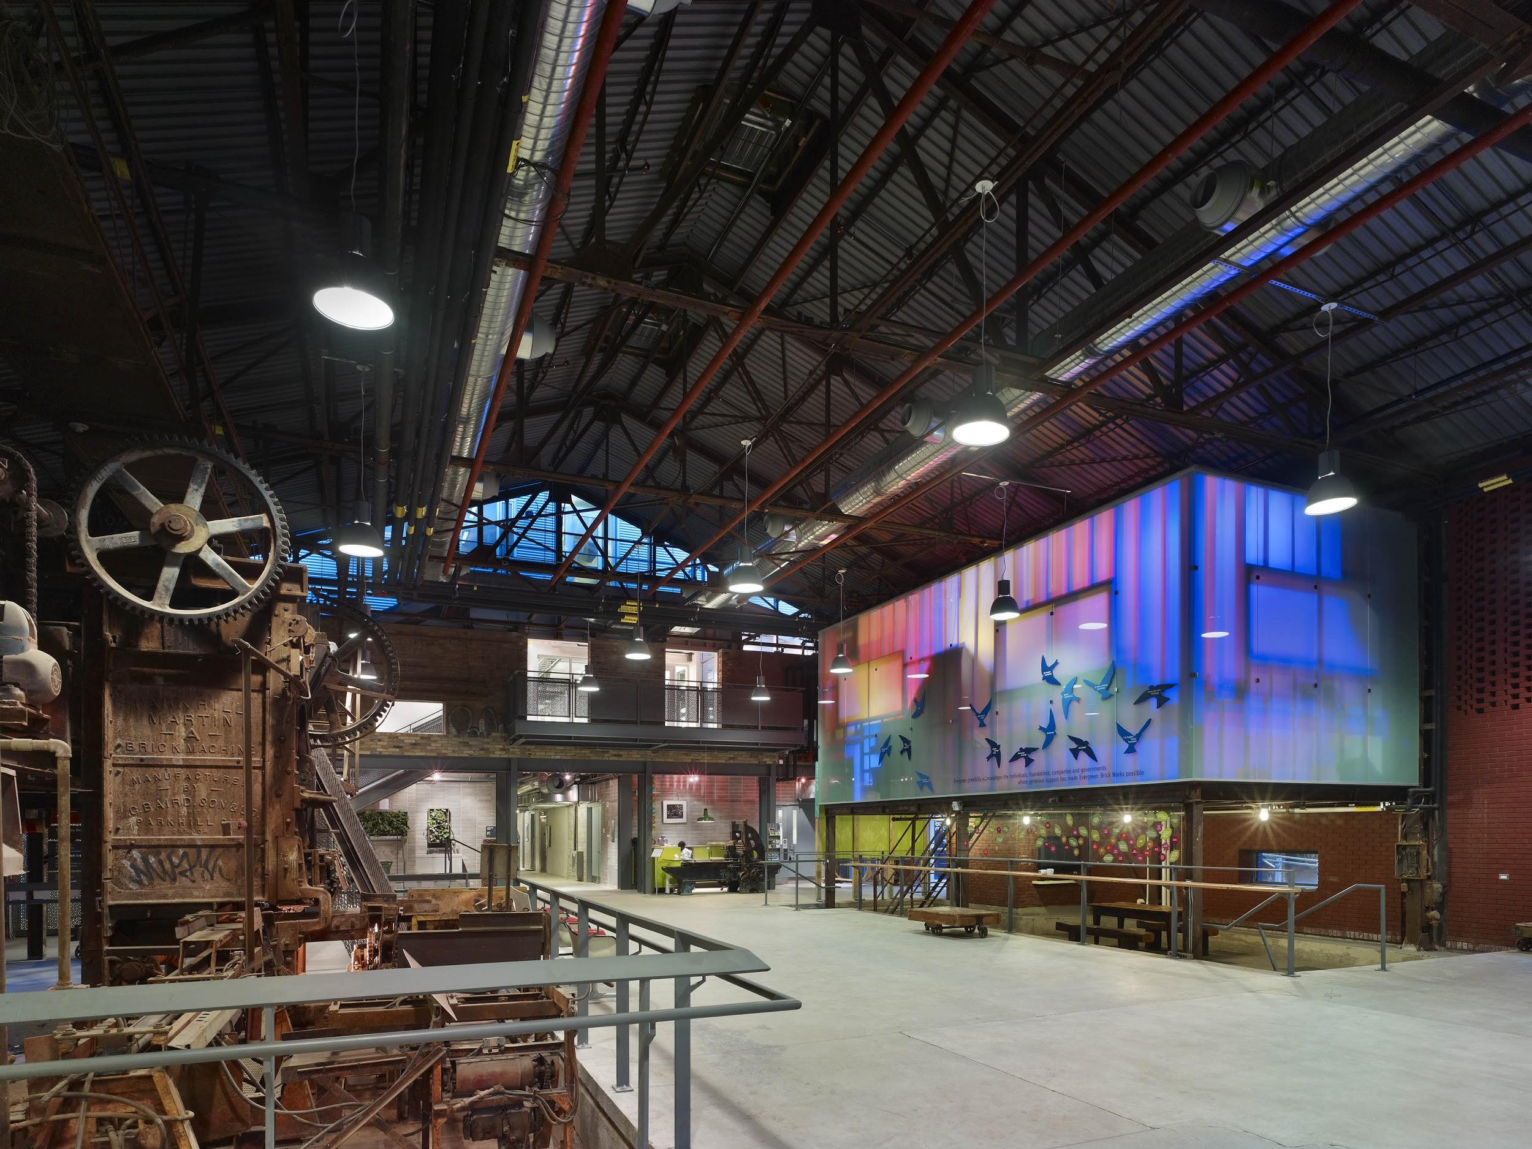

**Arrival & Registration**

*6:00pm at Evergreen Brick Works in the BMO Atrium.*

Participants should arrive at 6:00pm to register for the event. Participants will be given a name tag indicating their area of expertise to help facilitate team building and brainstorming. After registering, participants have until 7:00pm to mingle and network with other participants.

**Event Kick-off & Briefing**

*7:00pm*

At 7:00pm the participant briefing will start. Participants will receive context for the types of problems that need solving and an overview of the hackathon event and rules.

**Dinner and Brainstorming**

*7:30pm*

Dinner will be served and participants will form groups and brainstorm ideas and solutions for traffic troubles.

**Team registration & setup**

*8:15pm*

Following dinner, participants will register as teams. Teams will need to fill out a team form listing their members’ names, team name and a one-sentence description of what they are hoping to achieve over the weekend. Single participants can compete as well as teams of up to 8.

**Hackathon begins once teams are formed and registered.**

**During TrafficJam**

*Day 2*

**Mentorship**

*Mentors will be available throughout the hacking period.*

Experts in traffic management and urban planning, data analysis, graphic design, data journalism and representatives of data collectors and distributors will be in attendance on Friday evening to anchor the discussions, point teams towards available resources and help validate concepts before participants go to work.

These experts from the city, regional and provincial agencies, non-profits, sponsors, academia and the entrepreneurial community in Toronto will also serve as mentors to participants throughout the hacking period and help keep the projects realistic and potentially usable.

**Food and Drinks**

*Food and drinks on us - all weekend!*

The TrafficJam team will be providing food, snacks and drinks throughout the entire weekend to keep participants energized and focused! We will do our best to meet various dietary needs, if you have specific requirements please [email us](mailto:contact@hackworks.com) and let us know in advance so we can be prepared.

**Meal Overview**

Friday: dinner & midnight snack

Saturday: breakfast, lunch, dinner & midnight snack

Sunday: breakfast, lunch & afternoon snacks

**Meeting Rooms**

*Meeting rooms are available on site.*

Located on the second floor of the Centre for Green Cities are four meeting rooms that range in size and can be arranged in multiple configurations. These rooms will be used for breakout groups during the brainstorming and team building sessions as well as for team meetings with mentors throughout the hackathon.

**After TrafficJam**

*Day 3*

**Finish Line**

Hackathon ends at 2:30pm on Sunday October 4th. There is a short break to allow participants to get ready to demonstrate their projects.

**TrafficJam EXPO**

*Sunday, October 4th, 3:00pm – 7:00pm*

All teams will present their submissions to fellow participants, judges and members of the public science fair-style at the TrafficJam EXPO.

**Judging & Awards**

*Sunday, October 4th, 5:30pm – 6:30pm*

The judging will be done in three phases. First the TrafficJam teaa Selection Committee will narrow down all submissions to the top ten. Then the Judges will review the Top 10 and determine the winners. The winners will be announced at the end of the event and awarded their prizes. Judging criteria will be shared closer to the event.

If you have any questions please [email us](mailto:contact@hackworks.com).

**\*\*Weekend Schedule goes here\*\***